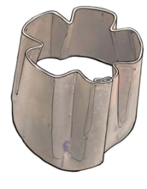
Build-It: Maize Sheller

Goals:

Participants learn to measure, hammer, cut, and manipulate metal with
pliers, and are introduced to the concept of a jig.

Each participant will make a hand-held sheet-metal sheller of their own

Time:

30 minutes

Things to Prepare in advance:

Be sure to have 4 jigs. If you don't have enough jigs, take plans to local welders to have them made. Jigs will almost always be the limiting factor to having a fast lesson

Be sure you know how to make a sheller; practice making a sheller yourself

Have samples of different-sized shellers to show people the variation possible

Keep the first aid kit on hand in case of any small cuts or nicks.

SetUp:

Try to find a location where there is plenty of workspace, light, and protection from the elements (if necessary.)

Arrange a comfortable workspace in a circle/semicircle, making sure everyone can see the demonstration.

What is needed to make a maize sheller
Tools |  | Materials
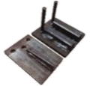 | Jig | Sheet metal (to be cut into 12"-wide strips of any length)  - 24 gauge/0.6mm/0.024" thickness is best  - 25 gauge/0.5mm/0.020" is easier to work with, but makes a weaker sheller  - 22 gauge/0.8mm/0.031" makes a strong sheller, but is very difficult to work with  Typically, sheet metal is found in 4 feet x 8 feet sheets. Find used sheet metal of different sizes at scrap yards or production sites of metal stoves, tins, cash boxes, metal storage containers, etc.  4’ x 8’ sheet for 70,000/= (Ugandan shillings)  One piece of sheet metal is enough for 100-150 shellers.  Total cost for each sheller 500/=
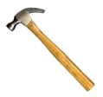 | Hammer
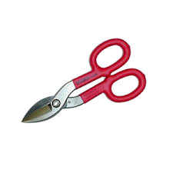 | Tin snips
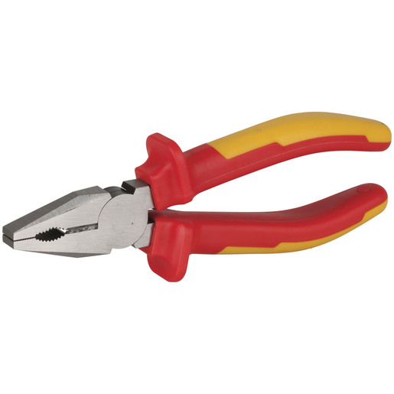 | Pliers (Needle-nosed pliers are ideal)
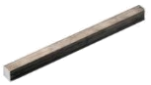 | Sturdy rod or pipe
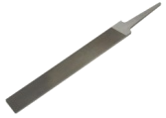 | File
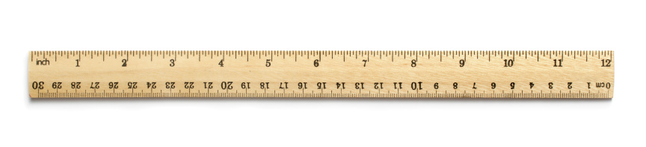 | Ruler
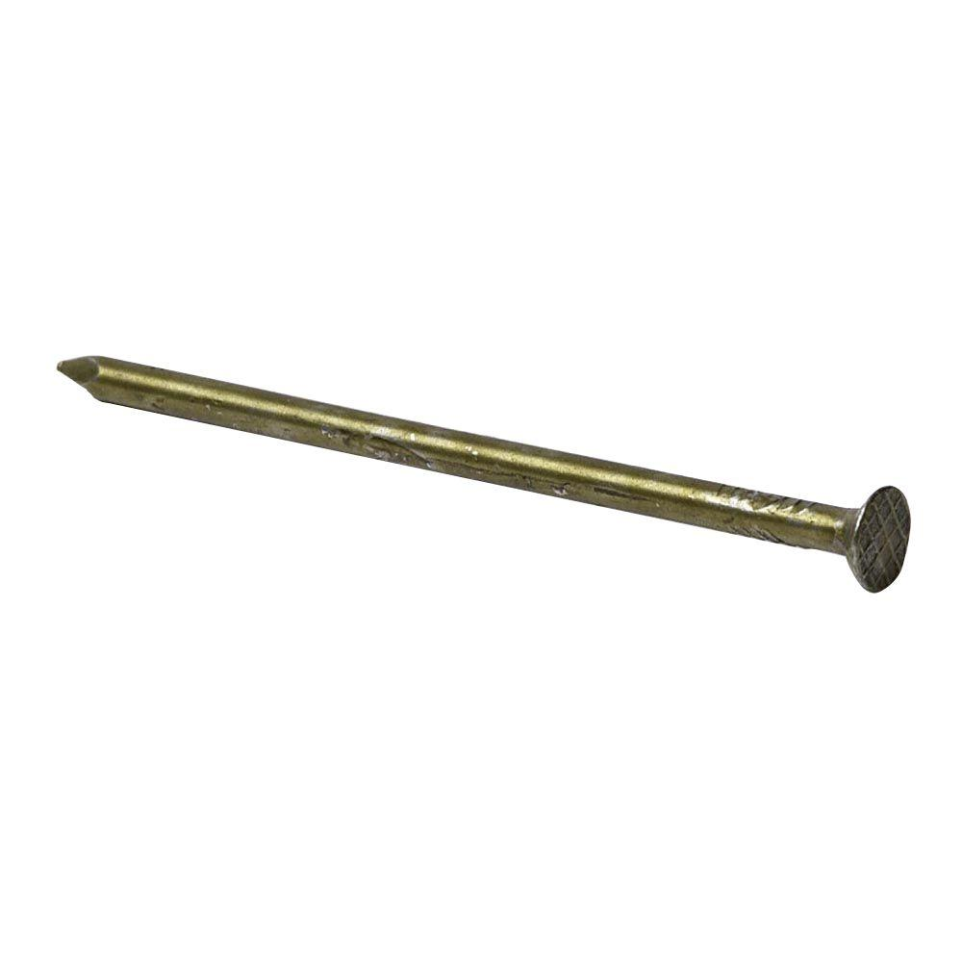 | Nail
 | Marker
Two wooden blocks
(or any two level surfaces—to balance the rod)
 | Large bag of dried maize on the cob
 | Basin or cloth to shell maize into/onto
 | First Aid Kit

- What is a Build-It?
A Build-It is a lesson where you will make a small technology yourself and learn some skills. We will all build together, step by step. Each member will have an opportunity to learn some hands-on skills by using some tools and materials. As you build the technology, you will be taught good techniques for handling metal and wood. At the end of the Build-It, you will have had some practice using tools and also have a technology for you to take home.
- What is a maize sheller?
Ask, "How do people currently shell maize?" Hold up a piece of maize. People usually shell with their thumbs.
This is a maize sheller and this is how it works.

Take out the hand maize sheller and remove the kernels from a piece of maize. People will probably be impressed!
Ask, "Would you like to learn how to make it?"
- Setting up the Build-It

ENcourage participation

Remind participants to ask questions when they have them! To probe for questions, ask participants questions, such as “What do you see as the benefits or drawbacks of this sheller?” or “Would you consider making one at home? Why or why not?” or "How else might you make this sheller?"

Organize into working groups
- Break up the group up into 4 groups of 4 participants each (or roughly teams of 4 or 5 participants each depending on how many people are in attendance).
- Distribute tool sets to each team. It is often easiest to have the tools set up before beginning the demonstration, or to have one of your co-facilitators ready to distribute the tools at the right time. Teams will need to share the tools.
- Throughout the Build-it, help teams share tools by walking around and seeing who is finished using their tools.

- Making the maize sheller

Show the participants all the materials that are needed to make a sheet-metal sheller. Introduce the jig, explain what it is used for and that you had it made by a local welder; include an estimate of the price ($2-$4 in the local currency).

Walk through each step of the procedure as you are doing it. For example, do Step 1 and then wait for each person in the group to complete that step before going on to Step 2. Continue in this fashion until everybody has completed the sheller.

If working with groups that have both men and women, be sure to encourage everyone in the group to take a turn using the tools.
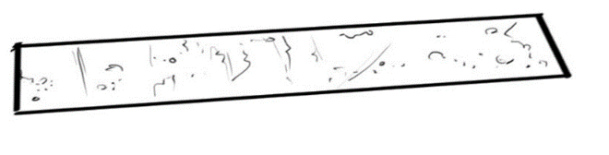
- Cut a strip of sheet metal with the tin snips, 2”x 9.5”
(5 cm x 24 cm).
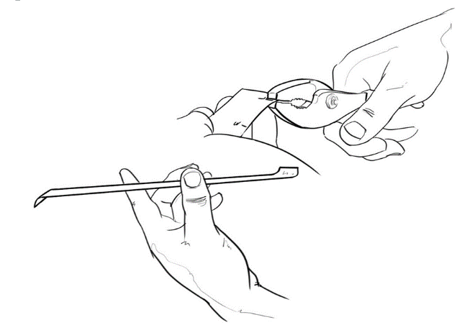
The length of the strip will depend on the circumference of your maize cob (without the kernels). The length of the strip should be approximately 4” more than the circumference of the cob (i.e. 9”[23 cm] for corn with a 5” [13 cm] circumference).
- With the pliers, bend down one centimeter tabs at either end of the strip in opposite directions. If you do not have pliers, use the hammer to bang the tabs over a straight edge, like a table.
They will make 90 degree angles (but in opposite directions).

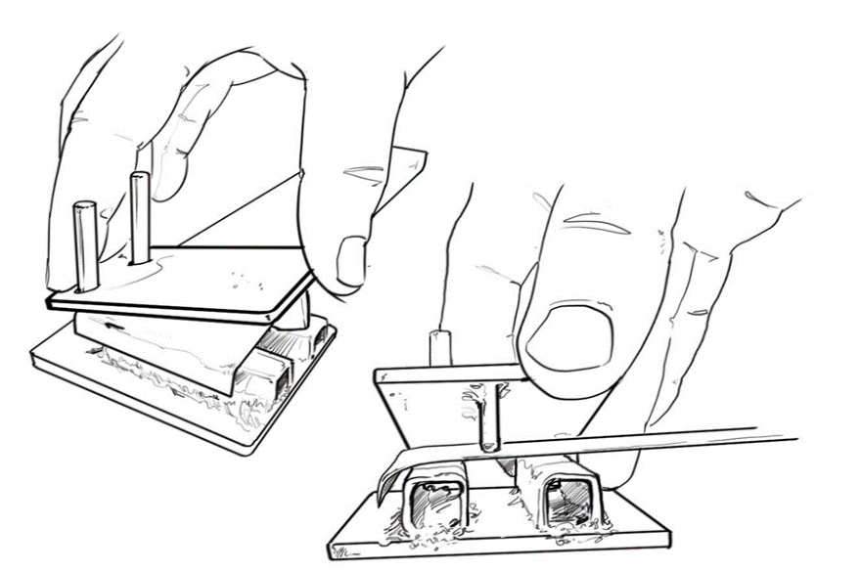
- Next, place the strip in the jig. Make sure that the edge of the strip lines up with the tooth of the jig, in order to make sure your ridges are deep enough.
Slide the strip all the way to one side so one of the tabs rests against one of the bars on the bottom of the jig.

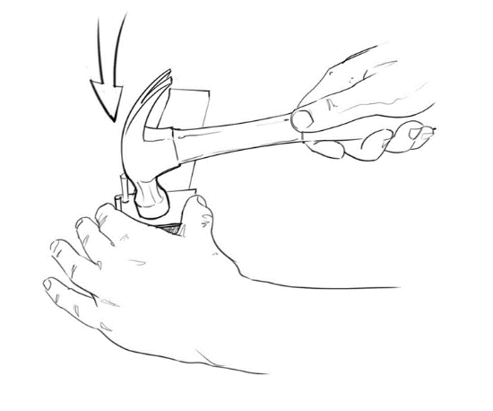
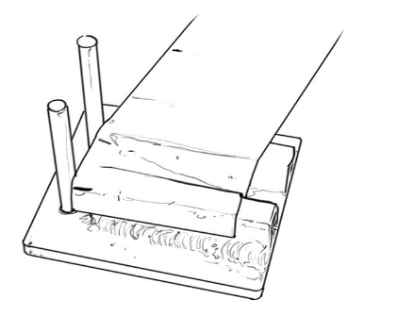
- Hold the jig top and strip firmly in place and then hammer down on the top of the jig.
You have created your first “ridge.”
Repeat this process by sliding the strip to the opposite side until it rests against the bar on the bottom of the jig. Hammer down again.
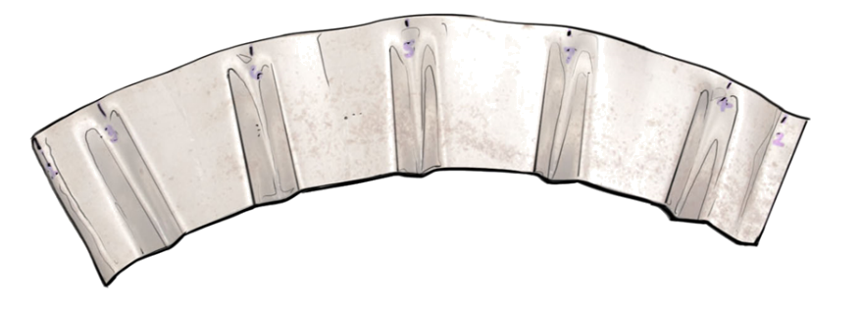
Estimate the middle point between the two ridges you have created and hammer down making the third ridge.
Make sure the ridges are all going in the same direction.
Next, estimate the middle point between the middle tooth and the tooth on the far left side, then hammer down to make your fourth ridge.
Next, estimate the middle point between the center tooth and the far right side, then hammer down.
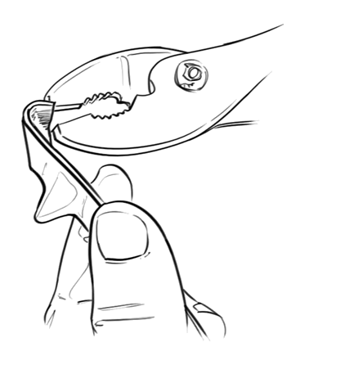
You have made all five ridges!
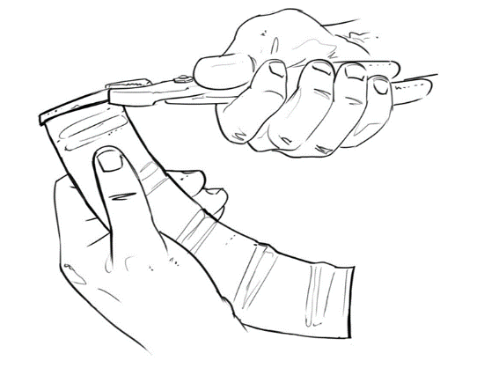
- With the pliers, curl the end tabs in more, so that they look like ‘C’.

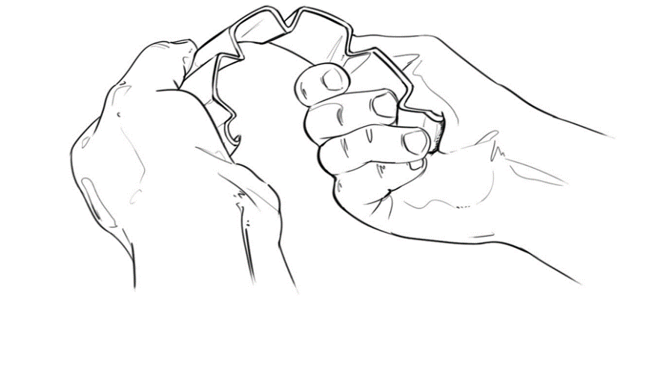
- Then, with your hands, bend the strip into a circle; be sure the ridges point INTO the circle!
It is helpful to curve one section at a time, slowly curving to make a nice circle.

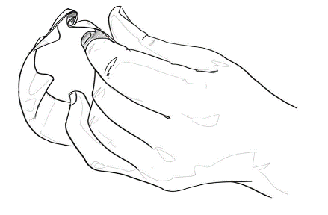
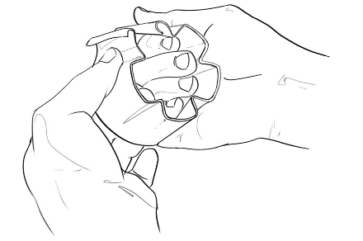
- Hook the tabs onto one another:

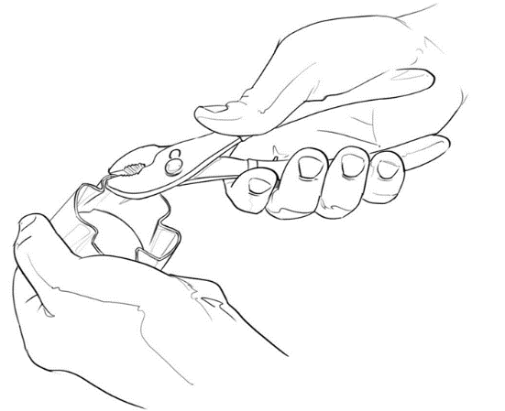
- Fold them over and flatten them a bit with the pliers.

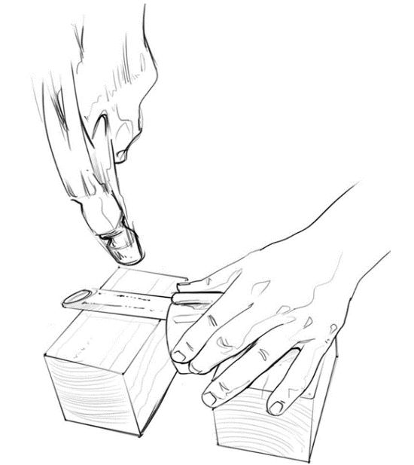

- It is likely the tabs are not completely flat; using the sturdy pipe between the two pieces of wood as an anvil, hit the crimped tab connection with a hammer on the anvil to make the attachment secure.

- The maize sheller is complete!

- Demonstrating the Resulting Product

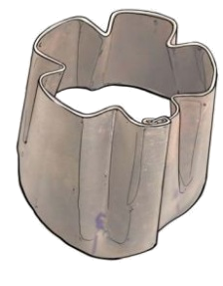
After completing the sheller, allow participants to try the shellers that
they just made!
Appendix – Design of the maize sheller jig
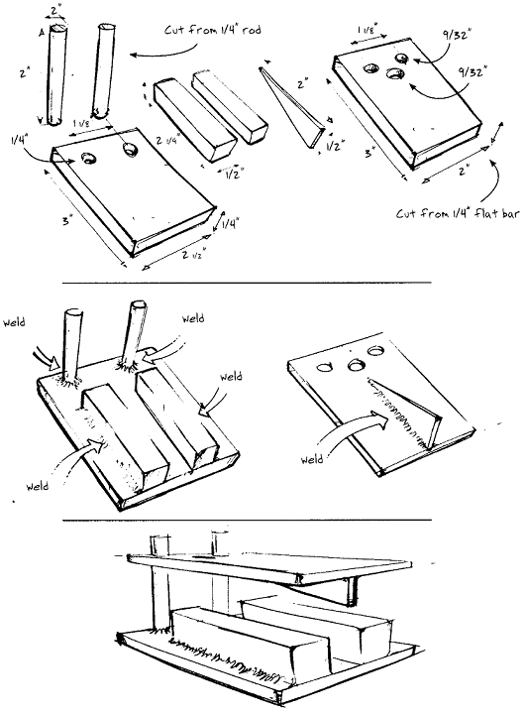
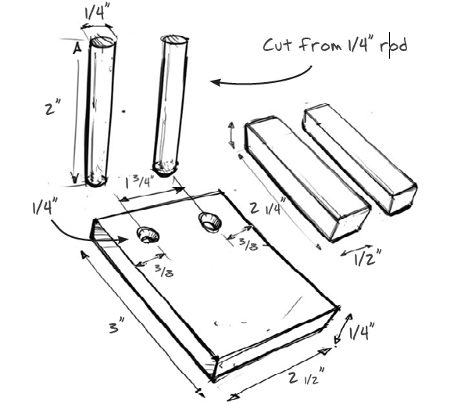
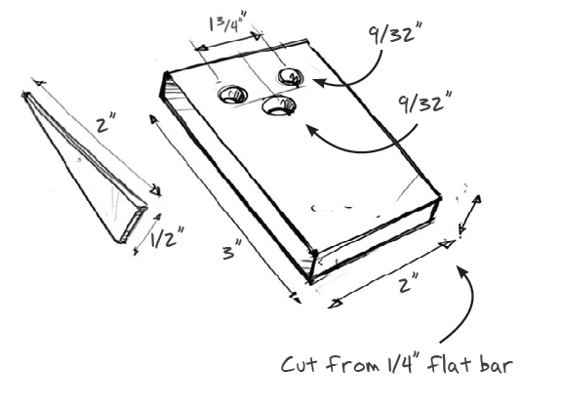

Appendix – Build-It: Maize sheller jig
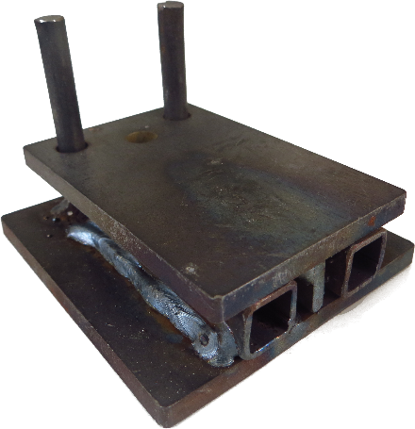

The jig is constructed from a few pieces of metal using a welder. The bottom piece measures 3” x 2.75” (length x width) while the top piece measures 3” x 2”.

What is needed to make a jig
Tools |  |  | Materials
 |  |  | Item |  | Amount | Cost
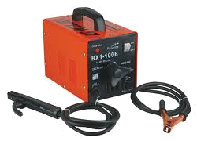 | Welding equipment |  |  | Steel Plate/steel flat bar
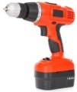 | Drill, with 1/4" and 5/16" bits |  | 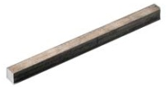 | Square steel rod, 1/2"
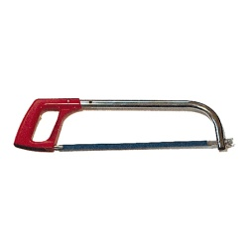 | Hacksaw |  | 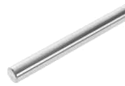 | Steel rod, 1/4"
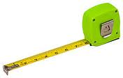 | Tape measure
 | Hammer
 | Metal file

Cutting and Drilling instructions

Bottom plate
- Cut two 2”-long pieces from a ¼” round rod.
The exact length of 2” is not important, but it is best if the rods are cut to be the same height.
- Cut a 2-½” x 3” piece from the ¼”-thick steel plate.
- Make two marks—3/8” from both the top and side of the plate, 1-¾” apart from each other.
- Drill holes on the two marks using a ¼” bit.
The distance from center to center of the holes should be 1-¾”. The space from the edge of one hole to the next should equal 1-½”.
- Cut two 2-¼”-long pieces from a ½” square rod.
The exact width of ½” is not important, but should be something similar.

Top plate
- Cut a 2” x 3” piece from the ¼” thick steel plate.
This steel should be at least ¼” thick – thinner steel will bend easily with the regular hitting of the hammer.
- Make two marks—3/8” in from both the top and side of the plate, 1-¾” apart from each other. (same as the bottom plate)

- Drill holes on the two marks using a 9/32” bit and a hole in the middle of the plate, ½” below the two holes (different from the bottom plate!)
Two holes are for the rods from the bottom plate to fit over. The hole in the middle is to look through to see the sheet metal (so that you can see the marks and know where to crimp the sheet metal).
- Fit the top plate over the bottom plate to make sure it fits well.

- Next, cut a triangular piece, measuring 2” x ½”
(if your square steel bar was a different size, change the ½” to equal the width of the bar). Cut a triangular piece measuring ½” x 2” from a 3/16”-thick sheet metal.

Assembly instructions

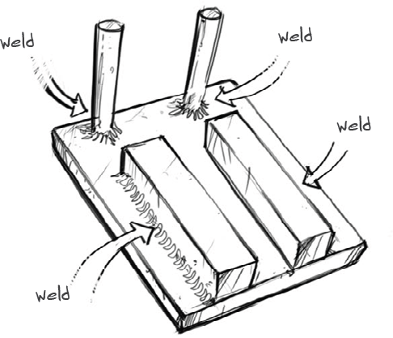
Bottom plate
- Press fit the 2” rods into the holes in the bottom plate, employing the help of a hammer if necessary. Spot weld to secure it in place.
- Weld the ½” square pipe onto the bottom plate, with a ½” distance between them.

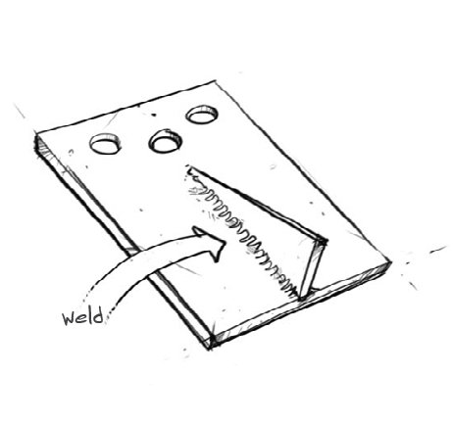

Top plate
- Weld the triangular piece onto the top plate, below the middle hole of the top plate.

- You’re finished! Crimp away!
